server.js:
const express = require('express');
const bodyParser = require('body-parser');
const fs = require('fs');
const cors = require('cors')
const path = require('path')
const app = express();
const DATA_FILE = path.join(__dirname, 'students.json');
app.use(cors());
app.use(bodyParser.json());
app.use(express.static('public'));
function readStudents() {
if (!fs.existsSync(DATA_FILE)) return [];
const data = fs.readFileSync(DATA_FILE, 'utf8');
return JSON.parse(data || '[]');
}
function writeStudents(data) {
fs.writeFileSync(DATA_FILE, JSON.stringify(data, null, 2));
}
app.get('/students', (req, res) => {
const students = readStudents();
res.json(students);
});
app.post('/students', (req, res) => {
const { name, marks } = req.body;
const students = readStudents();
const newStudent = {
id: Date.now(),
name,
marks: Number(marks)
};
students.push(newStudent);
writeStudents(students);
res.json(newStudent);
});
app.delete('/students/:id', (req, res) => {
const id = parseInt(req.params.id);
let students = readStudents();
students = students.filter(s => s.id !== id);
writeStudents(students);
res.json({ message: 'Deleted successfully' });
});
app.listen(3000, () => console.log('🚀 Server running at http://localhost:3000'));

index.html:
<!DOCTYPE html>
<html lang="en">
<head>
<meta charset="UTF-8">
<title>Student Management System</title>
<link rel="stylesheet" href="style.css">
</head>
<body>
<h1>🎓 Student Management System</h1>
<div>
<h3>🔍 Search Student Marks</h3>
<input type="text" id="searchName" placeholder="Enter student name">
<button id="searchBtn">Search</button>
<p id="searchResult"></p>
</div>
<hr>
<form id="studentForm">
<h3>➕ Add New Student</h3>
<input type="text" id="name" placeholder="Enter student name" required>
<input type="number" id="marks" placeholder="Enter marks" required>
<button type="submit">Add Student</button>
</form>
<table>
<thead>
<tr>
<th>ID</th>
<th>Name</th>
<th>Marks</th>
<th>Action</th>
</tr>
</thead>
<tbody id="studentTable"></tbody>
</table>
<script src="script.js"></script>
</body>
</html>
Style.css:
body {
font-family: Arial, sans-serif;
background: #f7f9fc;
text-align: center;
padding: 20px;
}
h1 {
color: #333;
}
form {
margin-bottom: 20px;
}
input, button {
padding: 10px;
margin: 5px;
border-radius: 5px;
border: 1px solid #ccc;
}
button {
background-color: #007BFF;
color: white;
cursor: pointer;
}
button:hover {
background-color: #0056b3;
}
table {
margin: 0 auto;
border-collapse: collapse;
width: 70%;
}
th, td {
border: 1px solid #ccc;
padding: 10px;
}
Script.js:
const form = document.getElementById('studentForm');
const tableBody = document.getElementById('studentTable');
const searchInput = document.getElementById('searchName');
const searchBtn = document.getElementById('searchBtn');
const searchResult = document.getElementById('searchResult');
async function loadStudents() {
const res = await fetch('/students');
const students = await res.json();
tableBody.innerHTML = '';
students.forEach(s => {
const row = `<tr>
<td>${s.id}</td>
<td>${s.name}</td>
<td>${s.marks}</td>
<td><button onclick="deleteStudent(${s.id})">Delete</button></td>
</tr>`;
tableBody.innerHTML += row;
});
}
form.addEventListener('submit', async (e) => {
e.preventDefault();
const name = document.getElementById('name').value;
const marks = document.getElementById('marks').value;
await fetch('/students', {
method: 'POST',
headers: { 'Content-Type': 'application/json' },
body: JSON.stringify({ name, marks })
});
form.reset();
loadStudents();
});
async function deleteStudent(id) {
await fetch(`/students/${id}`, { method: 'DELETE' });
loadStudents();
}
searchBtn.addEventListener('click', async () => {
const name = searchInput.value.trim().toLowerCase();
if (!name) {
searchResult.textContent = 'Please enter a student name.';
return;
}
const res = await fetch('/students');
const students = await res.json();
const found = students.find(s => s.name.toLowerCase() === name);
if (found) {
searchResult.textContent = `✅ ${found.name}'s marks: ${found.marks}`;
} else {
searchResult.textContent = '❌ Student not found.';
}
});
loadStudents();

OUTPUT:

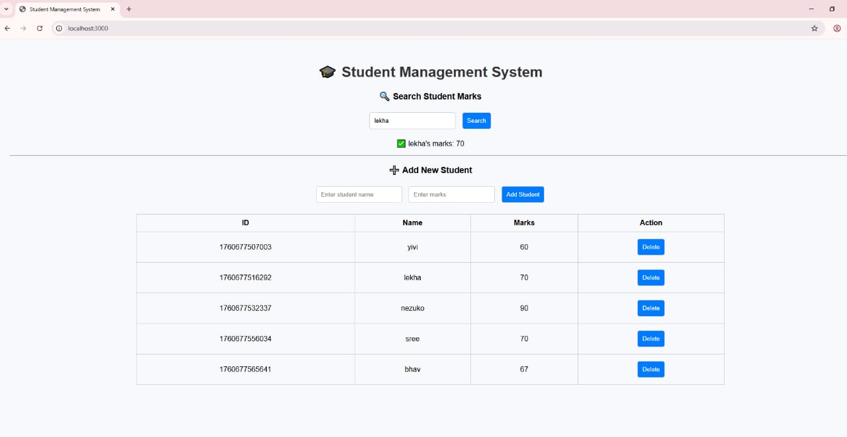

RESULT:

